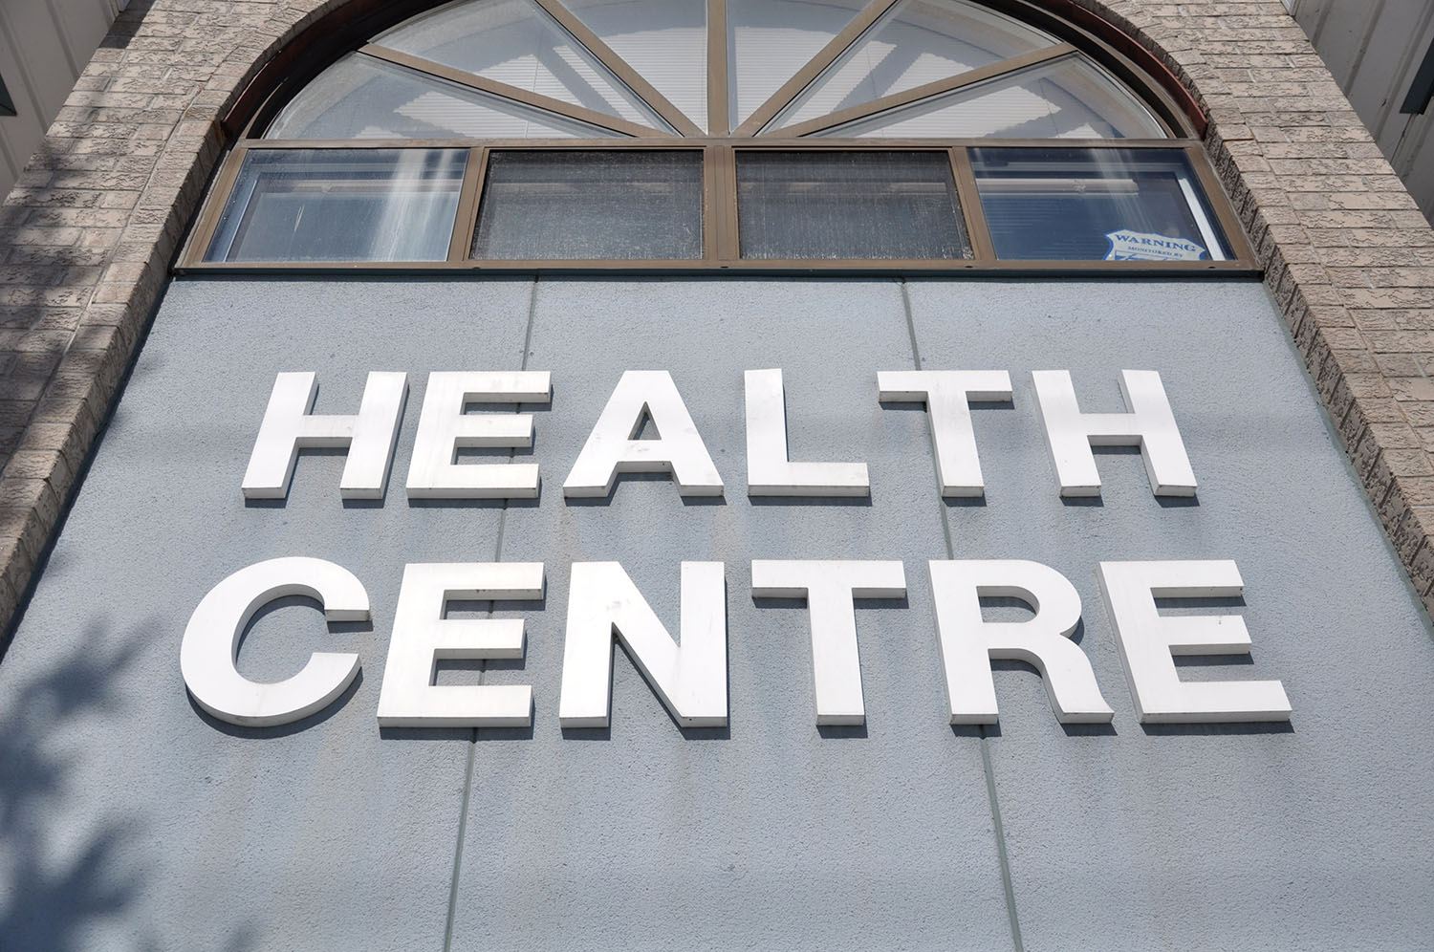

MY HEALTH CENTRE

POLICY AND PROCEDURES MANUAL

1 July 2020

2. WORKPLACE HEALTH AND SAFETY

This Centre is committed to preventing workplace injury and illness and ensuring a safe and secure working environment for doctors, staff, clients and all other visitors.

It is a legal duty of every workplace to maintain standards to protect the health, safety and welfare of every person within the workplace This includes staff, clients, visitors and anyone else who may enter the premises.

All our workers have a duty of care to ensure that they work in a manner that is not harmful to their own health and safety and the health and safety of others.

All staff should be advised of the risks of infection and be encouraged to be immunised against vaccine-preventable diseases to prevent transmission of disease to and from staff and clients. Staff should be offered additional vaccinations where appropriate depending upon the likelihood of their contact with clients and/or blood supply substances. These vaccinations may include Hepatitis A and other disease vaccinations
.
This Centre has a designated elected health and safety representative (HSR). The name and telephone extension of our HSR is kept on the staff notice board. Information relating to WH&S issues are posted on the notice board/conveyed to all members of staff and updated regularly by the HSR. We consult with employees on matters that may directly affect their health, safety or welfare and the HSR, is also involved in the consultation
We ensure workers have adequate information, instruction, training and supervision to work in a safe and healthy manner. Ergonomic furniture is available to reception and office staff and guidelines provided for working safely at the computer.
We maintain the workplace in a safe condition (such as ensuring fire exits are not blocked, emergency equipment is serviceable, and the worksite is generally tidy) and provide staff with adequate facilities (such as clean toilets and hygienic eating areas).
To support the safety, health and wellbeing of our staff we have policies and procedures in the following areas:

- tasks involving manual handling are identified and measures are taken to reduce or eliminate the risk of injury to doctors and staff as far as reasonably practical.

- incidents and all injuries involving all staff and clients and others that occur in the workplace are documented and managed professionally and ethically, according to relevant medical standards and guidelines.

- at induction and periodically all staff are instructed in safety and infection control protocols ensuring risks are known and precautions taken, including staff immunisation.

- we strive to work together to maintain a safe physical work environment that supports the health and wellbeing of doctors, staff, clients and visitors. Including ensuring regular breaks, adequate staffing levels and a smoke free environment.
- we have a duty of care to safeguard the health of employees which covers psychological as well as physical health.

- we strive to encourage consultation between management and staff on all matters pertaining to WHS matters as obligated under the legislation.

- we endeavour to provide a working environment in which all doctors, staff, clients and visitors are not subject to unlawful discrimination, sexual harassment, violence or bullying.

- non-medical emergency procedures and fire safety precautions are clearly documented, and designated members of the emergency team have a clearly identified roles and responsibilities.

2.1 Hazardous Substances
Our Centre does not use cleaning agents or other chemicals, which are known to be toxic to the user, such as glutaraldehyde and chlorine based products. Chemicals and cleaning agents used in our centre are used according to the manufacturer’s instructions.

All containers of chemical agents are appropriately labelled. This is to ensure that the contents of containers can be readily identified and used correctly. For this reason, labels must be kept fixed to the container at all times and clearly understood.

The safe use, handling, storage and transport of chemicals and hazardous substances is maintained by-
- regular audits of products used by the Centre.
- placing safety data sheets on equipment and hazardous substances
- maintaining a register of hazardous substances
- instructing staff members on how to handle hazardous substances appropriately
- storing containers of chemicals in a cupboard out of the reach of children
- training staff in the correct and safe use of chemicals.

2.2 Manual Handling
Manual handling is any activity requiring the use of force exerted by a person to lift, push, pull, carry, or otherwise move or restrain any animate or inanimate object. It includes activities involving awkward posture and repetitive actions. Manual handling injuries account for nearly 50% of all Workcover claims. Risk factors likely to cause manual handling injuries and therefore included in risk assessments include:

- force applied
- actions and movements used
- range of weights
- how often and for how long, manual handling is done
- where the load is positioned and how far it has to be moved
- availability of mechanical aids
- layout and condition of the work environment
- work organisation.
- position of the body whilst working
- analysis of injury statistics
- age, skill and experience of workers
- nature of the object handled.

.Procedure
Before doing any type of manual handling staff are required to assess the situation ask the following questions:
- should two people be lifting this or am I able to lift this safely and without risk or injury?
- is my pathway clear of all objects?
- what distance am I going?
- can I see clearly?
- can I split the load to make it lighter?

Staff are reminded to avoid tasks that involve:
- twisting, bending or extensive reaching
- repeated or prolonged stooped posture
- lifting requiring extended reach
- repetitive lifts from below mid-thigh or using forceful movements
- prolonged bent neck posture when working on low flat bench
- repetitive tasks for a prolonged time
- using excessive force to push, pull or hold object

- prevent slips or falls by wearing appropriate footwear.
- ensure adequate lighting.
- clean area regularly; spills should be wiped up immediately.
- check equipment is in good working order and there is adequate space in which to work.
- reduce the size or weight of objects to be lifted or carried.
- weight limits: Seated – 4.5 kg. Standing – 16 to 20 kg. (For ideal conditions and with a compact load held close to the body and with a short carrying distance).

2.3 Risk Management
This Centre has designated the Centre Manager with primary responsibility for risk management including following up on incidents, injuries and adverse client events and near misses.

Risk assessment | The designated staff member conducts a thorough review of all the hazards relevant to the cause(s) of any injury that has occurred with a view to identifying appropriate controls
Risk control | Involves identifying and implementing all the practicable strategies to minimise subsequent similar events or eliminate/ reduce the causes(s) of the injury or incident.

Incidents that should be reported (regardless of whether harm has occurred) to assist with making improvements to minimise the risk of recurrence, include:
- needle stick injury or mucous membrane exposure to blood or bodily fluids.
- slip or fall.
- drug or vaccine incident (loss, misplacement or other).
- adverse client outcome.
- failure or inadequate client handover or identification of a client at the point of transfer of care.
- delayed treatment or delayed follow up or unnecessary repeat of tests.
- medication errors.
- any deviations from standard practice.

Staff are to use the Centre’s Incident Report form to report any slips, lapses or near misses or deviations in client care that might result in harm.

