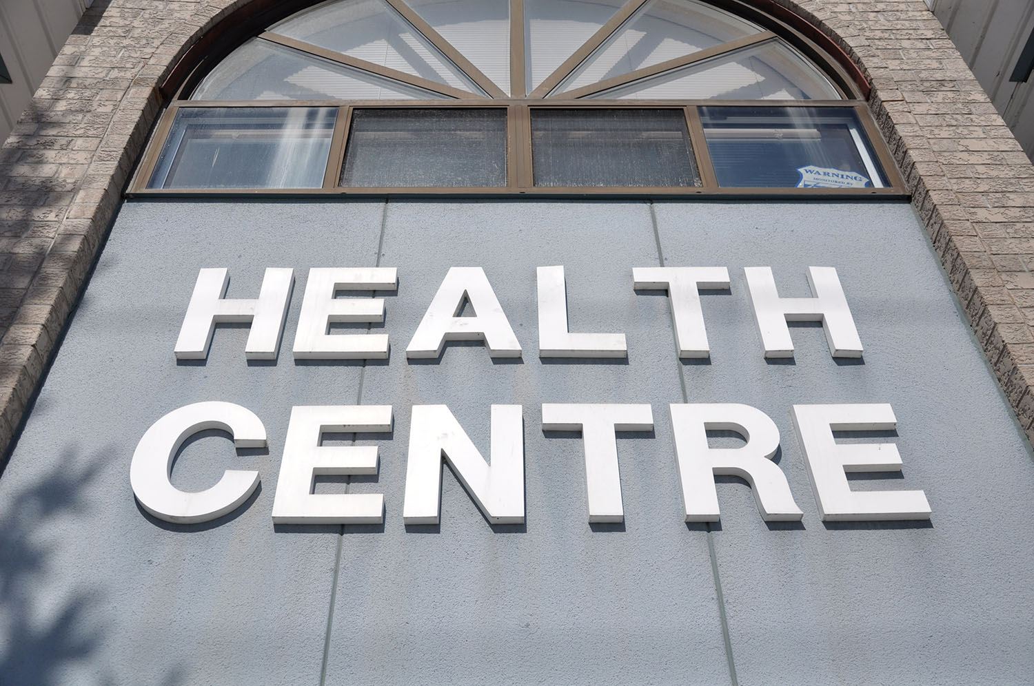

MY HEALTH CENTRE

POLICY AND PROCEDURES MANUAL

1 July 2020

1. INTRODUCTION

1.1 Mission Statement
My Health Centre is committed to providing its clients with a high standard of care for the benefit of their health and wellbeing.

Our mission is to provide the highest standard of care whilst incorporating a holistic and client centred approach.

We are committed to promoting health and wellbeing and controlling infection and disease. We do not discriminate in the provision of excellent care and aim to treat all with dignity and respect. We believe that clients come first.

Teamwork is highly valued and encouraged within the Centre to promote a harmonious and productive environment. We place great importance on ethical and responsible behaviour as being essential to maintaining the trust and loyalty of clients and staff.

1.2 My Health Centre Profile
Name of Centre
Street address
Postal address
In hours phone number
After hours phone number
Email address
Web address

1.3 Services
- Health Assessments
- Health Promotions
- Referrals
- Home visits

There is a range of posters, leaflets, and brochures about health issues relevant to the community available in the waiting room, the consultation rooms and at reception.
1.4 Centre Hours
Monday to Friday | Monday to Friday hours: 8.30am – 5.30pm
Saturday | Saturday hours: 8.30am -12.30pm
Sunday | Closed
Home visits | By arrangement : During daylight hours or after hours if unable to attend until after surgery. Home visit appointments can be made outside these times by prior arrangement with the receptionist at the discretion of the doctor.

